Repo link: https://github.com/CarlosvdK/Notiq
Prototyping Process

Step 1)
I made a mock version of my idea to conceptualise sort of what I wanted to do, my first idea was to add a feature to apple notes which uses ai to analyse your note and give smart suggestions based of the content.

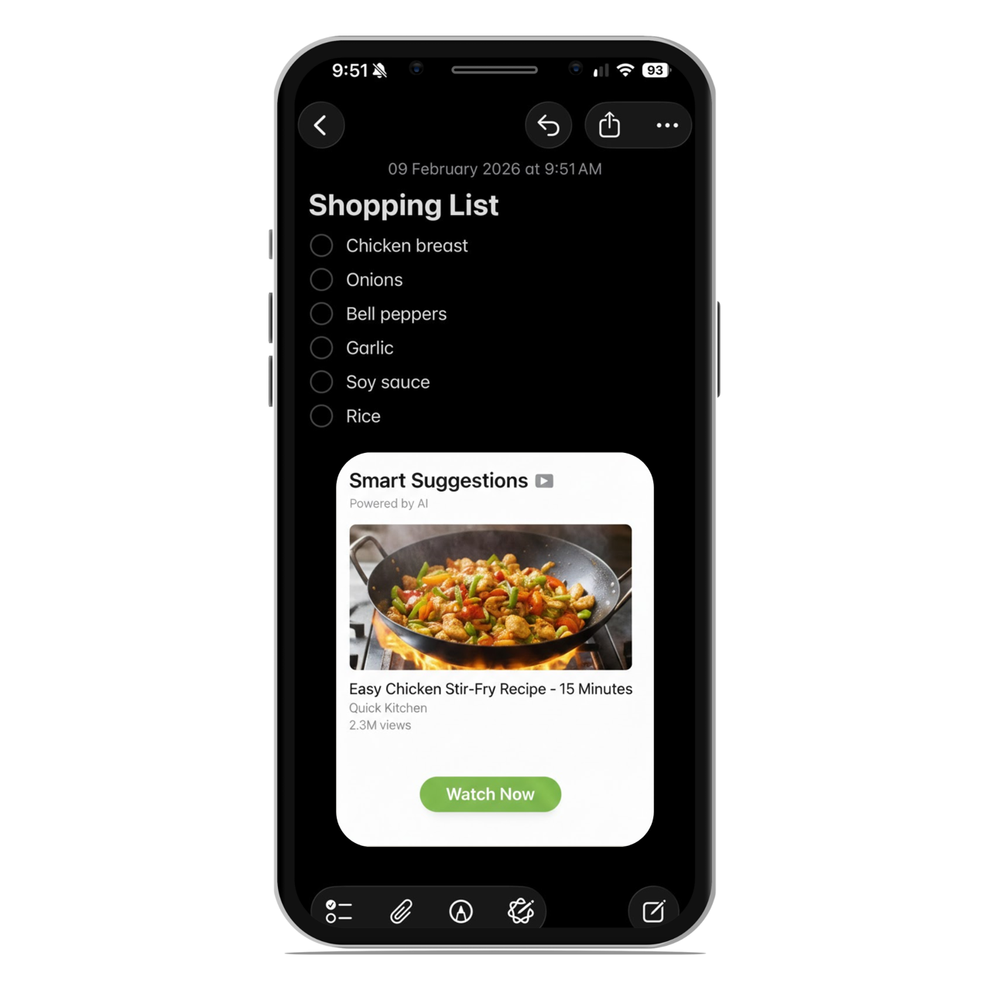

Step 2 (streamlit_v1.py):

I then changed my idea a little as I realised I would actually want this app but I would like to use it for university notes. So my first step was to make a basic version of the app, for this I used ai as a consultant so I essentially asked it what I would need for my idea and then I made a version for it which was only the UI so it had no utility and I made it through trial and error and asking AI.
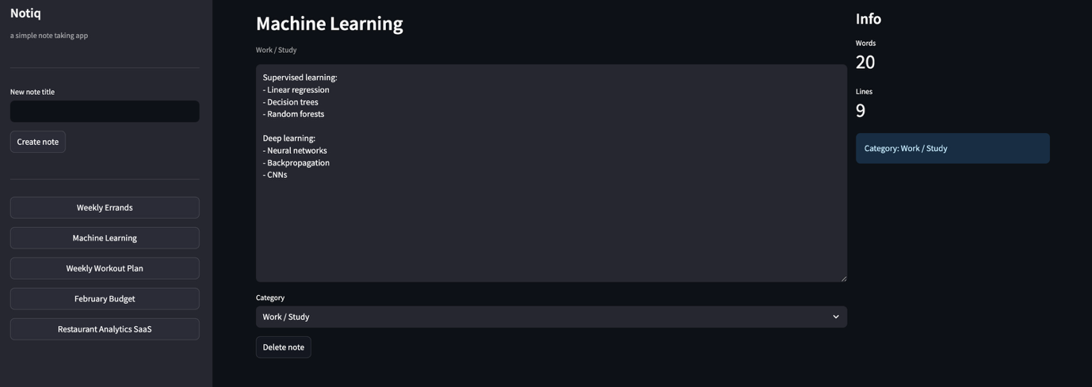

Step 3 (notiq_streamlit.py):

I then decided to use AI to improve the code, so I used Claude Code in my terminal and I prompted it to make changes that I thought would add value, this version also included AI to generate actual YouTube videos using the YouTube API and as well as including a chatbot which you can ask questions about your notes and then add them to your note pad immediately.

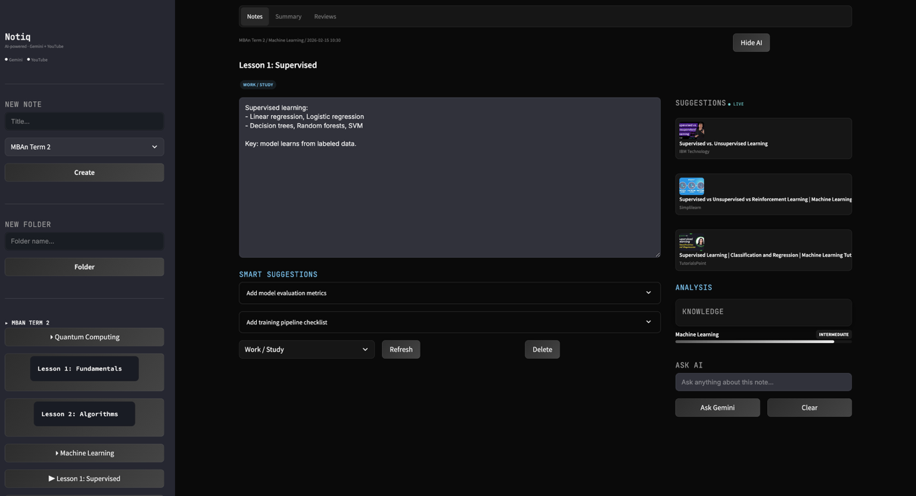

Step 4 (App.jsx):

I then realized that streamlit can’t do everything I want it to, for example I wanted to add ghost auto complete (similar to co-pilot) which lets you hit tab to autocomplete notes, the idea here is that when you’re in class it’s hard to pay attention while typing notes so you could start typing your note and then it gives autocomplete suggestions, I also added a drag and drop feature to the YouTube cards to improve usability.

